Adaptive reuse of Parramatta Town Hall

DA/828/2021

Comment on Development Application

The proposed Southern Annex (or Southern Extension) described in this Development Application appears likely to damage the heritage Convict drain (Item I647) adjacent to the Parramatta Town Hall.

I request that the design be amended to prevent damage to this heritage item.
The additional cost to achieve this outcome should be marginal.

Further details are described on the following pages…

Design Statement – 7 Parramatta Square

The document “Design Statement – 7 Parramatta Square” proposes a feature called the Southern Annex (or Southern Extension) on page 19. There are plans and other details described on page 20 – 22.

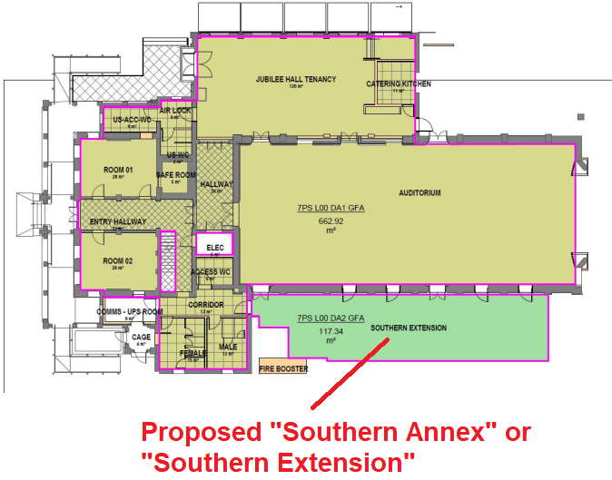

Complete Architectural Plans and Survey – 7 Parramatta Square

The document “Complete Architectural Plans and Survey – 7 Parramatta Square” shows this feature in the context of archaeological test pit results.
See Drawing number AR-DA1-1005, being the seventh drawing in this document.

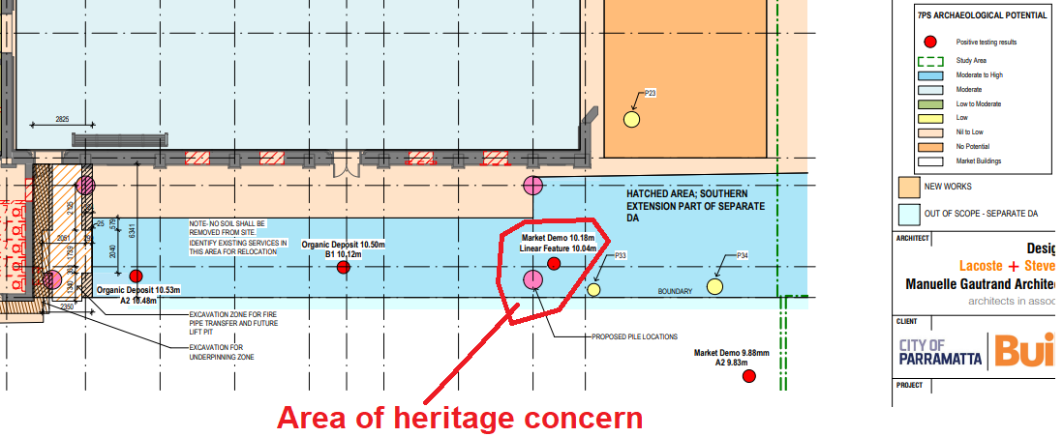

I have marked an “Area of heritage concern” due to the likely presence of a convict drain.

The test pit found a linear feature at 10.04m.
The “Proposed Pile Locations” for the new southern extension (or annex) is along the same alignment if it was the convict drain discovered in the test pit.

Statement of Heritage Impact – 7 Parramatta Square

The document “Statement of Heritage Impact – 7 Parramatta Square” describes the convict drain as Heritage item I647 (Convict drain) on page 6.

A map is shown in section 5.2.1 page 17 Statement of Heritage Impact

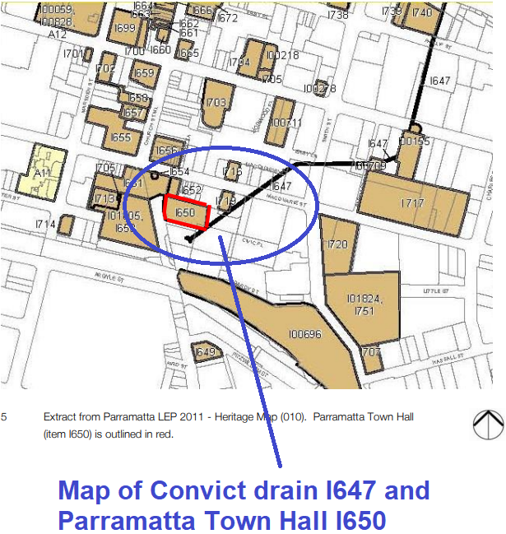
This map demonstrates the likelihood of the Convict drain being at the site of the “Proposed Pile Locations” of the new southern extension (or annex).

